Annual Report

2020-21

Municipal Committee Kamoke

Table of Contents
1. Background: 1
2. Functions of Municipal Committee Kamoke 2
3. Municipal Committee Organogram 3
4. Administrative Setup 4
5. Human Resource Available at MC 5
6. Annual Budget: 5
3. Covid – 19 (Response & Resilience) 6
4. Clean & Green Punjab Campaign 8
5. Khidmat Apki Dehleez Per 9
6. Anti-Dengue Activities 11
7. Trainings & Hands-on Sessions 12
7. Infrastructure Projects under PCP 14
8. Municipal Services Delivery Detail 15
8.1. Water supply system 15
8.1.1. Water supply hours 15
9.1.2 Total coverage of the city 15
9.1.3 Tariff structure 16
9.1.4. Water Filtration Plants: 16
9.1.5. Manpower Deployment 16
9.2. Solid Waste Management 16
9.2.1. Solid Waste Generation & Disposal 16
9.2.2. Equipment & Machinery 17
9.2.3. Manpower Deployed 17
9.2.4. Coverage Detail 18
9.3. Sewerage 20
9.3.1. Coverage 20
9.3.2. Existing pumping / disposal stations 21
9.3.3. Manpower deployed 21
9.3.4. Tariff structure 21
9.3.6. Drainage zones 21
9.4. Streetlight 22
9.4.1. Ward wise detail of existing streetlights 22
9.4.2. Replacement of luminaries 23
9.4.3. Provision of New Street Lights 23
9.4.4. Expenditure on streetlights 24
9.5. Complaint Management 25
9.6. MC Website (www.mcKamoke.lgpunjab.org.pk) 26
Annex A 27

Foreword:

On behalf of the Municipal Committee Kamoke, I hereby present this Annual Report for the financial year 2020-21. The report will give an insight into the performance and achievements of the Municipal Committee achieved during financial year 2020-21. The current Annual Report outlines MCs successes in relation to our mandate as mentioned in the key focus areas of Local Government Act. This can be summarized as; Building a Municipal Committee that is efficient, effective and responsive; Strengthen Accountability and promote fairness in its dealings; Accelerating Service Delivery and supporting the vulnerable; Promoting Economic and Social development; Fostering Development Partnerships, Social Cohesion and Community Uplift Programs. It is pertinent to note that these endeavors’ can never be successfully achieved on their own but it becomes materialized by the collective efforts of officers, officials and support staff who work together in identifying challenges and to meet those challenges with rigorous efforts and earnest professional approach.

It is commendable to note the improvements in relation to our spending and expenditure patterns, but we need to do more. The ever-present excuse of lack of resources might be a legitimate one, but the key question is how effectively we use the resources at our disposal to accomplish our goals and attaining set targets. It is clear in this annual report that we are moving in the right direction. It is of paramount importance to synchronize our program plans with quarterly targets to achieve our broader goals effectively and efficiently.

Chairman
Municipal Committee
Kamoke

Background:

The city is headquarter of Kamoke Tehsil, which is an administrative subdivision of the district Gujranwala and is subdivided into 36 Wards. Kamoke city was settled in the era of Akbar. It was declared a tehsil in 1992.

Kamoki is administered by Municipal Committee Kamoke district Gujranwala. It has Tehsil Civil Courts, its own circle of police, and a Tehsil Headquarters hospital. The city of Kamoke is located at 74°-15’ East and 31°-48' North at Main GT Road (N-5) at a distance of 59 km from Lahore in north and 21 Km from Gujranwala at its south. It is a railway station on Lahore Rawalpindi section and is connected with entire province through rail and road links.

The city has extremes of climate. The summer season starts from the month of April and continues till October. May and June are the hottest months with day temperature usually ranging from 39 to 47 degree centigrade. The winter season begins from the month of November and continues till March. January is the coldest month with a mean minimum temperature of 5 degree centigrade. Dust storms occur occasionally during the hot season relieving temporarily the intensity of heat. Towards the end of June monsoon conditions appear and during the following two and half months spell of rainy season alternates with intervals of sultry weather. Most of rain falls in July, August and September during summer months and in January, February and March during the winter months. The average rain fall in the district is about 635 millimeters.
The District Population Census Reports of the year 2017 have not been published by Government of Pakistan as yet. However the provisional results published by Government for census 2017 for the Punjab Cities show the population of 166,652 persons for Kamoke city. As per land scan process conducted by PMDFC Kamoke city had the population of 235659 in the year 2017 with an annual growth rate of 2.56 % and it is expected to rise to 303,433 persons in the year 2027.
Economic Activities in the City
Kamoke is known for its rice, which are grown in its surrounding areas. Kamoke is also the largest rice market a large number of power Looms, power press in the sub-continent where almost all kinds of rice, which include, Basmati, Super Basmati, Karnal etc. are grown, processed and exported to the world.

Functions of Municipal Committee Kamoke

Municipal Committee Kamoke is responsible for performing the following functions as per new PLGA 2019:

- Economic and value chain development;
- Management of primary, elementary and secondary education facilities;
- School enrolment and universal education;
- Monitoring and supervision of primary health care facilities;
- Preventive health and hygiene;
- Population welfare including population control;
- Solid waste collection and disposal;
- Sewerage collection and disposal including water management and treatment;
- Building control and land use;
- Births, deaths, marriages and divorce registration;
- Museums and art galleries;
- Open markets;
- Livestock and agriculture markets;
- Public parking facilities;
- City roads and traffic management;
- Public transport;
- Abstraction of water for industrial and commercial purposes;
- Emergency planning and relief;
- Support to provincial agencies in prevention of crime and maintenance of public order; and Regulatory enforcement in the functions
- Establishment and management of pre-schools;
- Libraries;
- Drinking water supply;
- Burials, cremations etc.;
- Public conveniences;
- Children's services;
- Community safety;
- Arts and recreation;
- Public fairs and ceremonies;
- Sports;
- Environmental health, awareness and services;
- Parks and landscape development;
- Slaughtering of animals;
- Street lights; and
- Sign boards and street advertisements.

Municipal Committee Organogram

Administrative Setup
Administrator
Ms. Hira Rizwan
Ph. No. 0556-811542

Chief Officer  Muhammad Umer Nasim  Ph. No. 0556-811542 | 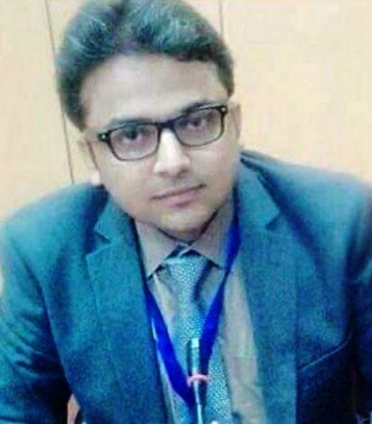
Dy Municipal Officer (Finance)/ Public Information Officer (PIO)  Mian Muhammad Akram  Ph. No. 0556-814441 | 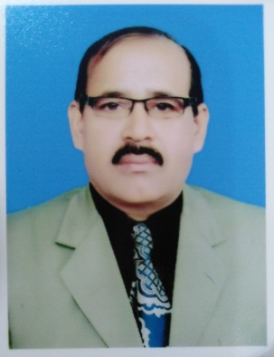
Deputy Municipal Officer (Infrastructure & Services)
Mr. Asif Farzand
Ph. No. 0556-811542
Deputy Municipal Officer (Regulation)
Ms. Sumaira Sami Ullah
Ph. No. 0556-811542

Deputy Municipal Officer (Planning)  Hafiz Muhammad Tayyab Attique  Ph. No. 0556-811542 | 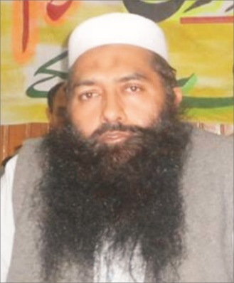

Human Resource Available at MC

Vacancy Analysis-Section Wise
Section | Sanctioned | Filled | Vacant
Mayor | 7 | 4 | 3
Chief Officer | 20 | 17 | 3
Municipal Officer (F) | 23 | 19 | 4
Municipal Officer (IT) | 6 | 3 | 3
Municipal Officer (R) | 18 | 16 | 2
Municipal Officer (P) & (A) | 14 | 9 | 5
Municipal Officer (I&S) | 373 | 194 | 179
Total | 461 | 262 | 199
Municipal Committee Kamoke schedule of establishment is attached as Annex – A

Annual Budget:

Covid – 19 (Response & Resilience)

As early as late 2019, MC management was aware of and beginning to prepare for COVID-19. Administratively, the management began preparing of pandemic plans and connected with other community stakeholders. This helped the city be prepared when we started seeing cases in Kamoke. As the COVID-19 situation continued to evolve, the city of Kamoke took precautionary measures to protect both staff and the community against the spread of Coronavirus. In response to the increasing levels of response required to follow the recommendations of health professionals. The city of Kamoke activated and mobilized its emergency team to curb the pandemic and to avoid as many people from the grip of this disease. By taking emergency measures, the city was able to nimbly respond to the constantly changing environment that COVID-19 presented.

Throughout the pandemic, the city has had three main goals:

- To implement the Standards Operating Procedures (SOPs), protocols and decisions taken by the National Command and Operation Centre (NCOC), Government of Pakistan
- To protect the health and safety of staff throughout the duration of the Pandemic;
- To protect the health and safety of the residents by taking precautionary measures;
- To ensure the provision of critical services to the residents, health care facilities, and businesses.
- To create awareness campaigns and messages to sensitize people, residents and other stakeholders time to time.

City Administration hosted weekly group meetings with the hospital, Augustana, senior’s care providers, and school board officials in order to pool information and share what the municipality was doing. Keeping the public updated through social media, print media and motivational materials was a top priority.

 | 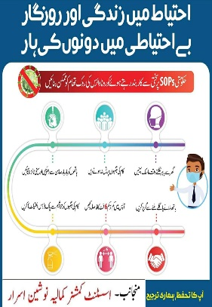
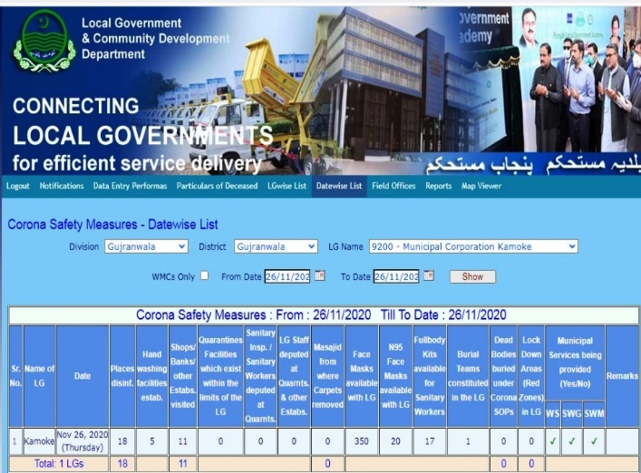 | 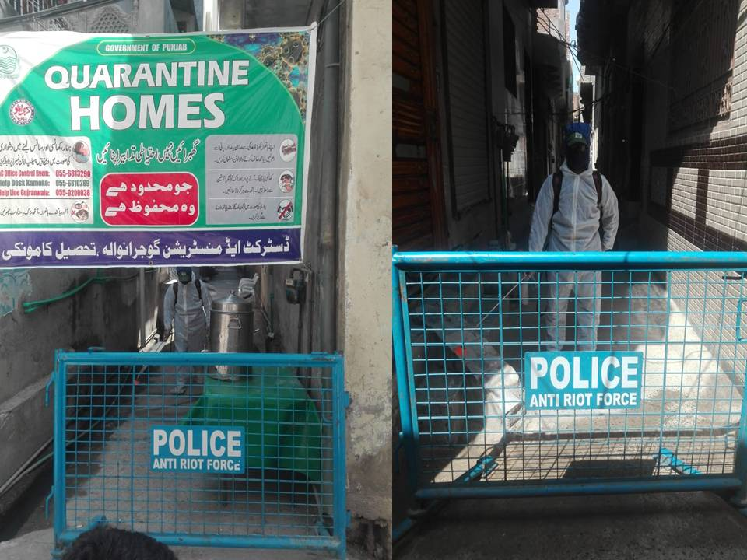
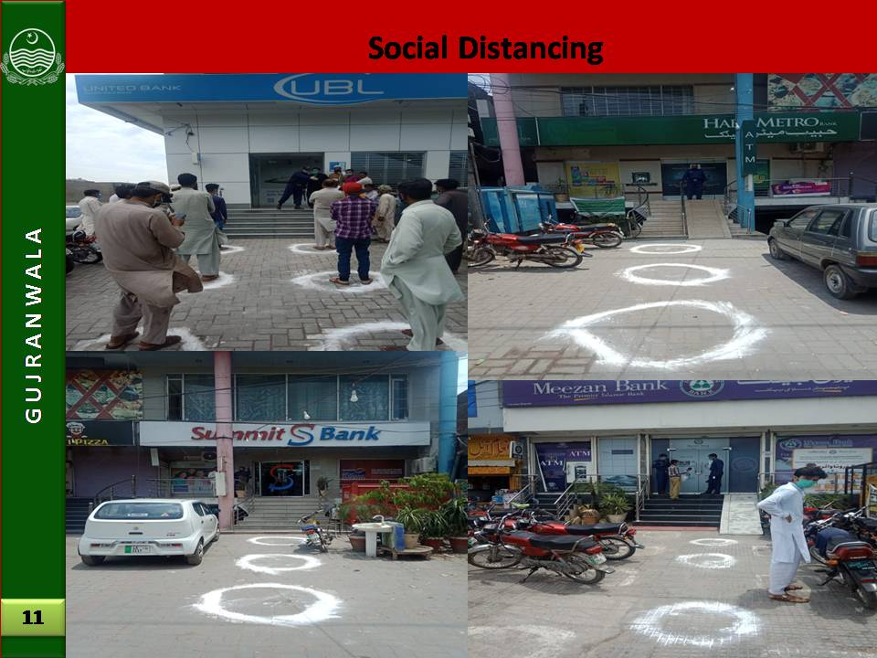 | 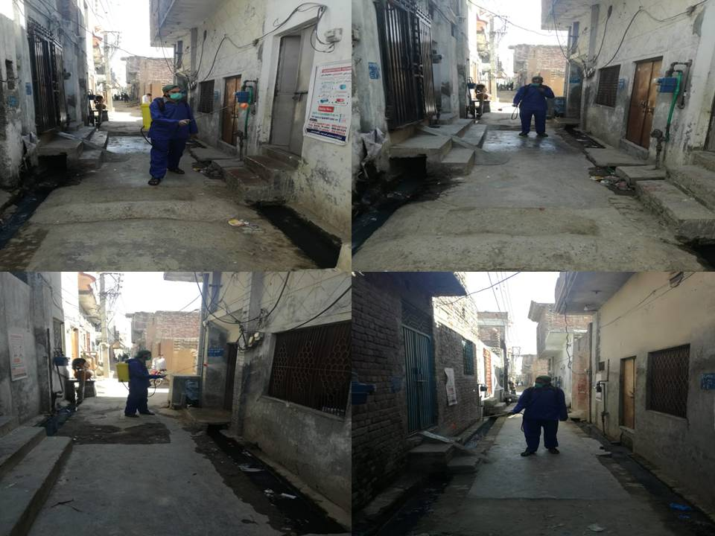
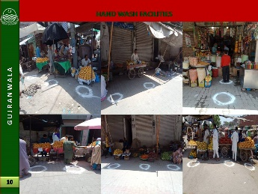
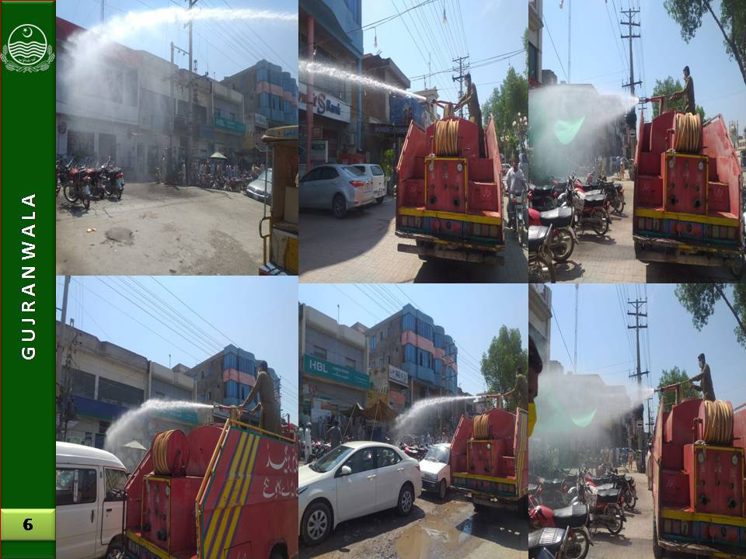 | 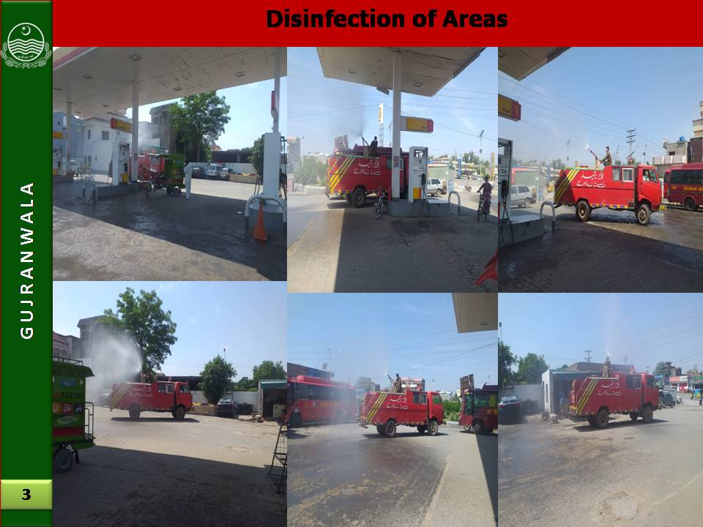

Clean & Green Punjab Campaign

Punjab Government launched an initiative of Clean Green Punjab to make the Punjab clean and green. The Clean Green Punjab campaign included tree plantation, beautification of cities, sanitation, providing safe drinking water, solid waste management and water waste management to its citizens of Municipal Committee Kamoke. MC took this initiative with full zeal and zest and put its best efforts to turn the city into the clean and green. MC understood that there was a dire need to plant tree to a large extent for ensuring pollution-free environment. MC took practical measures with all financial and human resources. MC also evolved a comprehensive awareness campaign for promoting tree plantation and serious efforts were made in this regard.
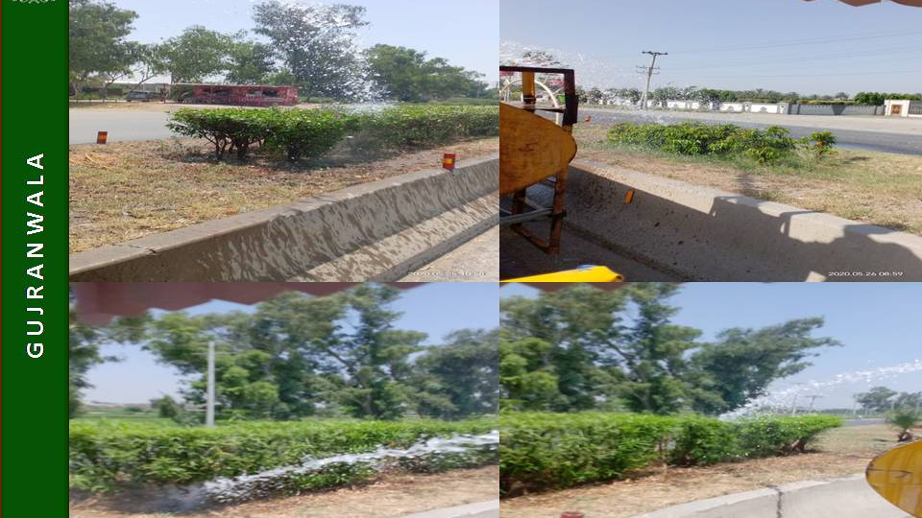 | 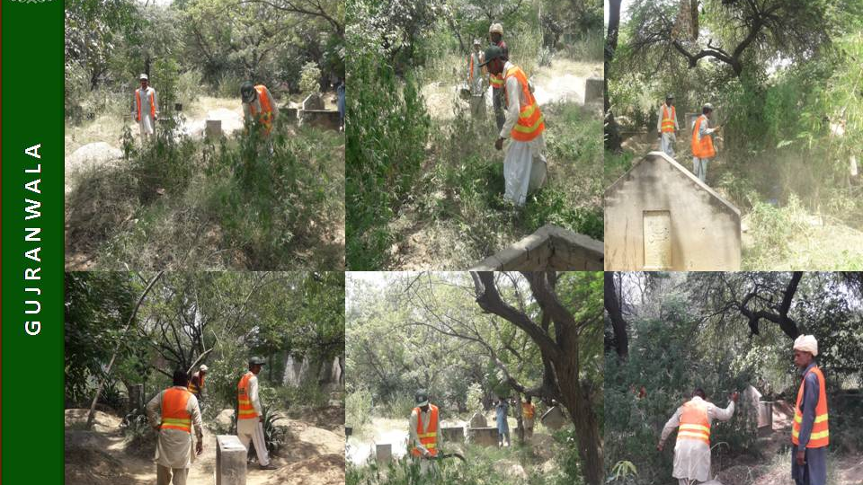
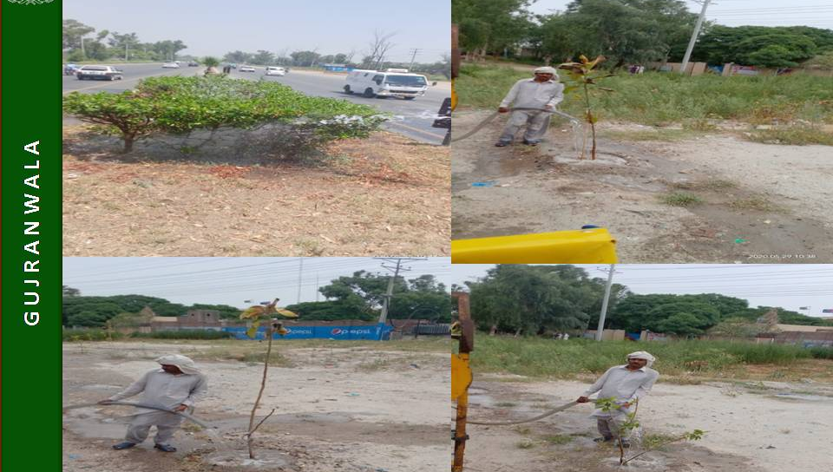 | 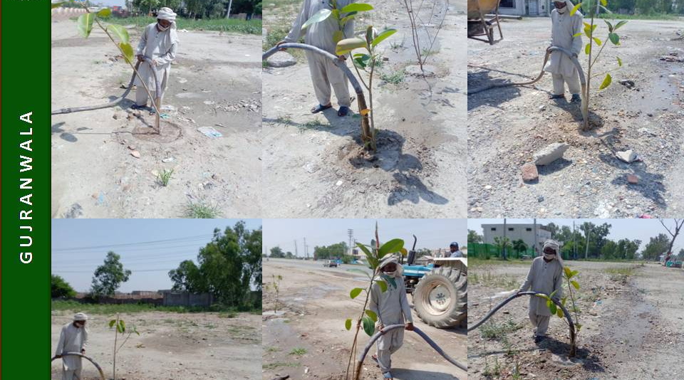
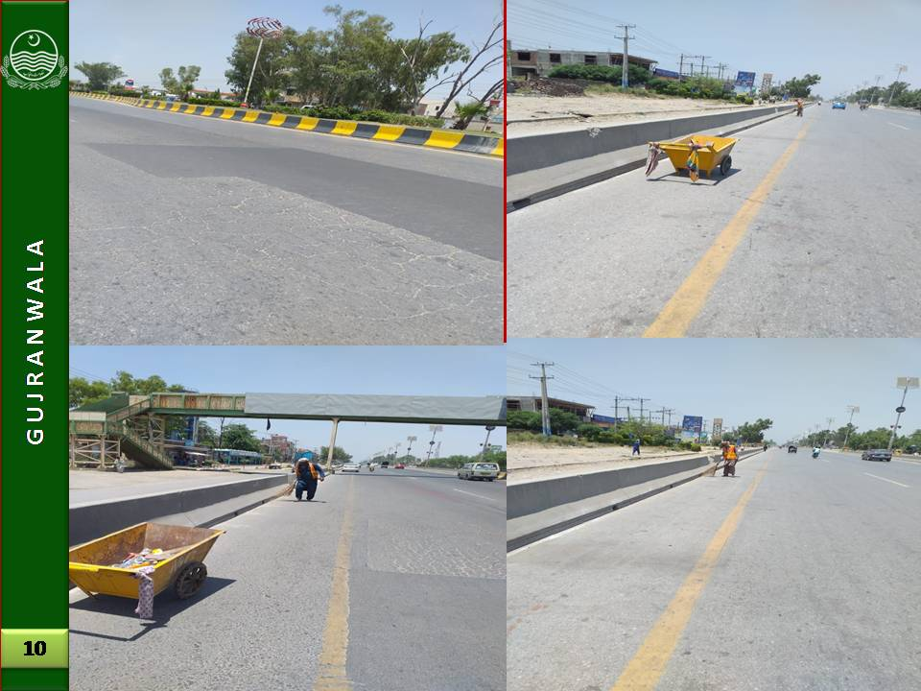 | 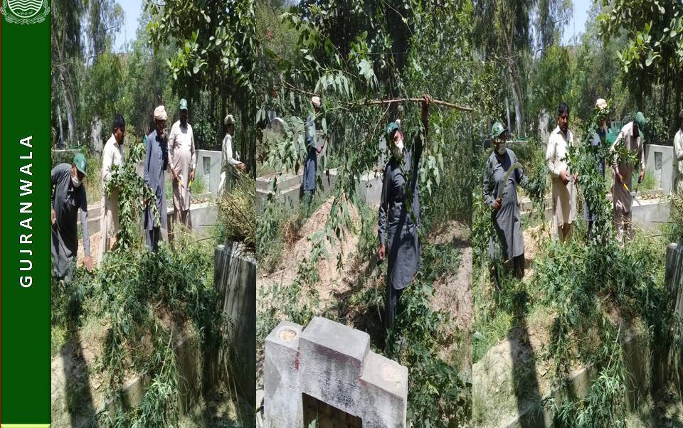

Khidmat Apki Dehleez Per

On the directions of Chief Minister Punjab, Sardar Usman Buzdar, 'Khidmat Apki Dehleez per' program was launched in the Kamoke City. The basic purpose of the program was to revive government machinery for effective delivery of services. Municipal Committee Kamoke were also given specific tasks in accordance with the needs of the public to ensure the effectiveness of service delivery mechanisms. The program was truly beneficial for the masses. Weekly schedule was issued in which the officers of municipal committee monitored the sanitation, sewerage and other matters in their allocated areas. The citizens were asked to identify/ highlight the areas that needs quick attention from Government departments, and Government officials will respond to their issues/suggestions. The activities under “Khidmat Apki Dehleez Par” program had been intensified to clean and beautify government buildings as well as parks, intersections and green belts in all areas of the city. Horticultural development was of great importance and for the purpose, MC Kamoke along with other departments in had taken special measures to beautify the city. The Administrator monitored the activities being conducted under the program Apki Dehleez Par to ensure that there was no delay in the resolution of people’s problems and all targets were achieved well in time.

 | 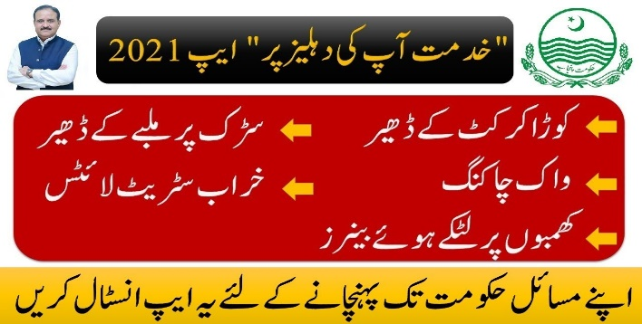
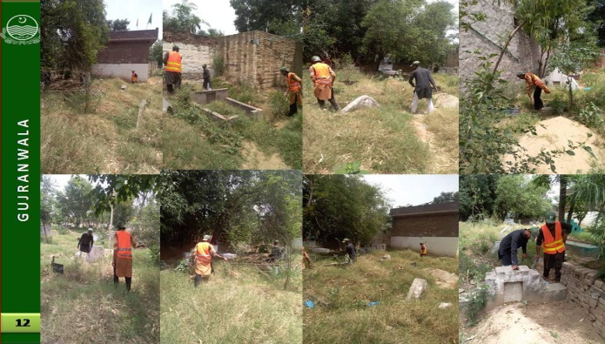 | 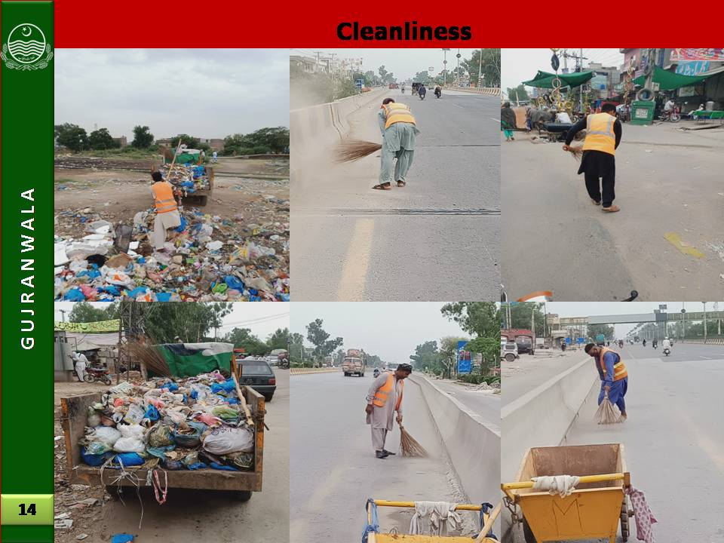
 | 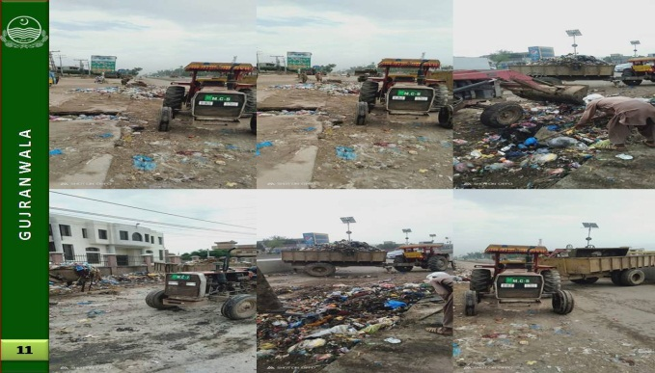
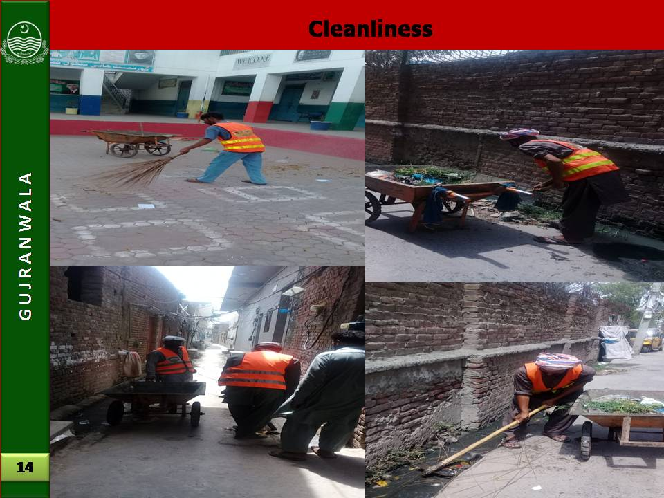 | 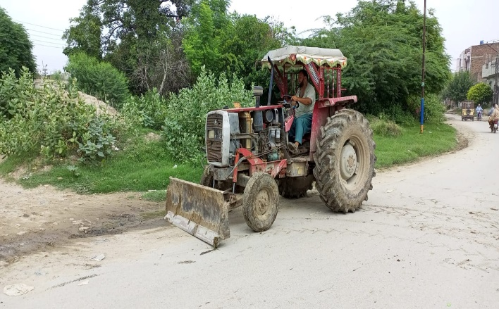
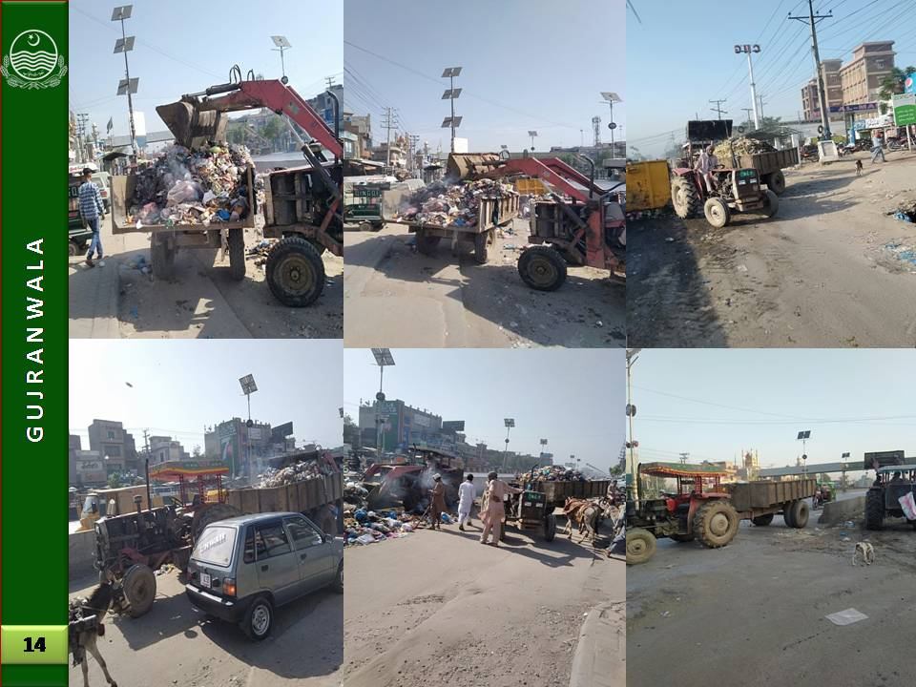 | 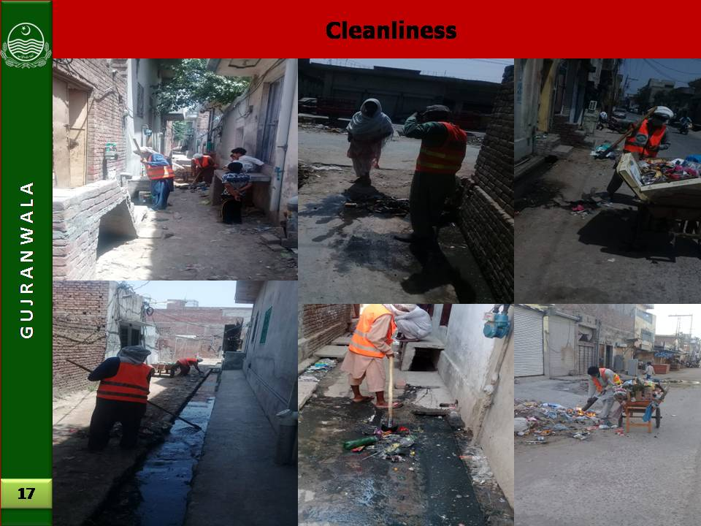
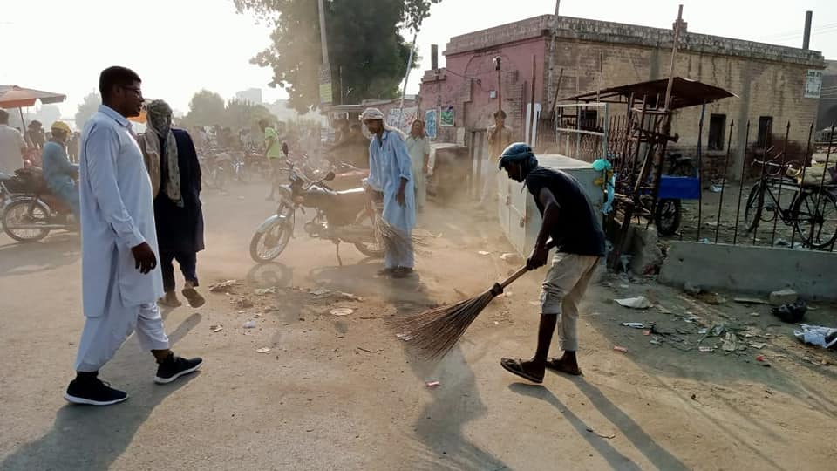 | 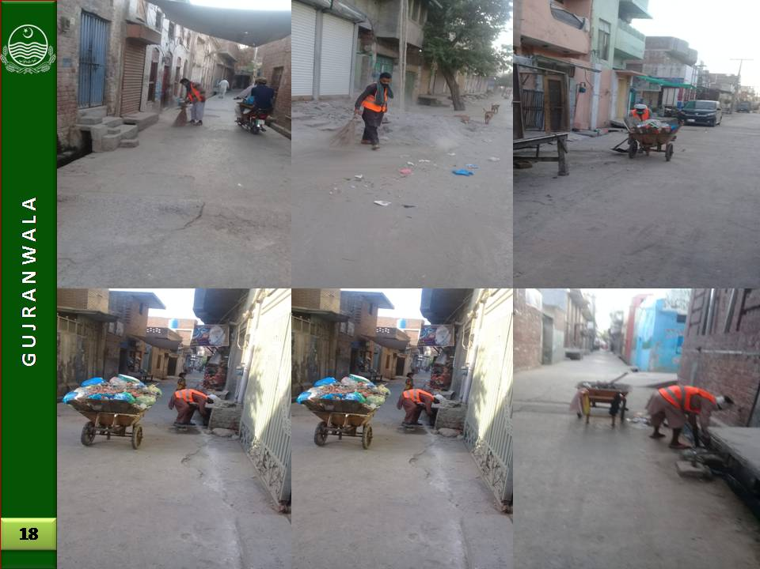
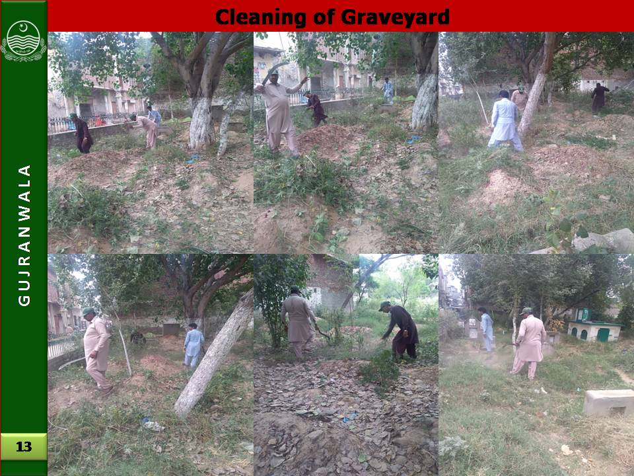 | 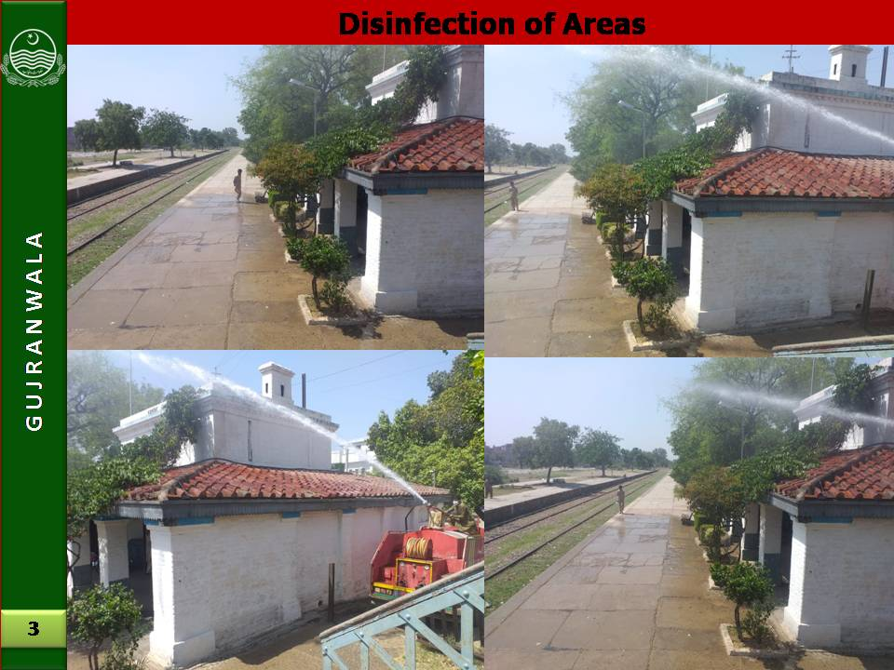

Anti-Dengue Activities

Dengue is a social problem and can be overcome only by including all segments of the society in the anti-dengue drive. By considering need of the hour, MC took steps to create awareness among the people to keep their houses clean and remove stagnant water. MC had been implemented anti-dengue regulations and stern action were imposed on their violators. MC management had given top priority to overcome dengue and special teams had been constituted to keep surveilling high risk areas. In this regard, daily surveillance schedules were prepared, micro plans were developed, field teams were mobilized and social segment of the society were activated to curb the wide spread of epidemic.

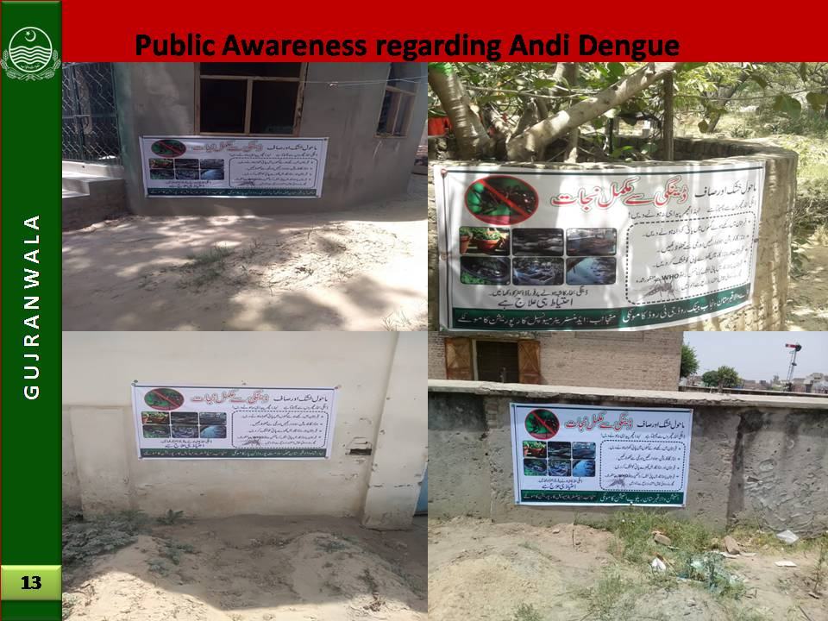 | 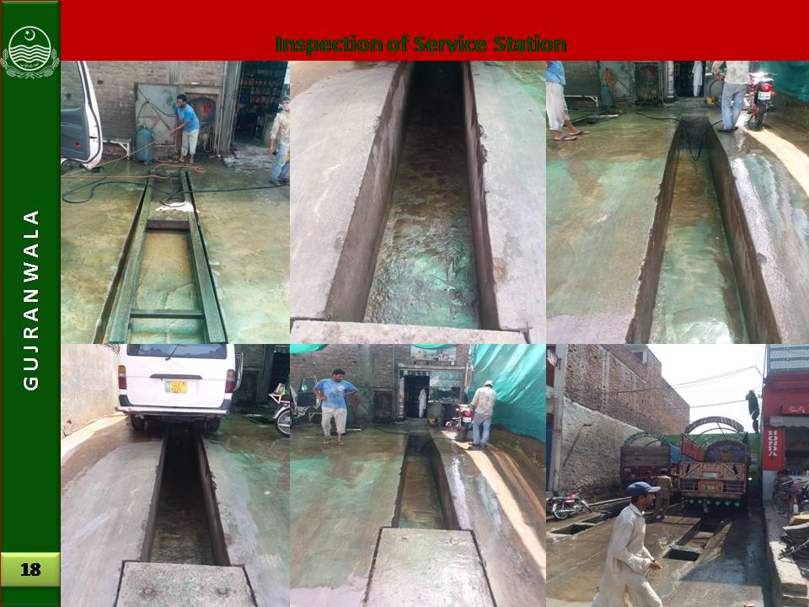
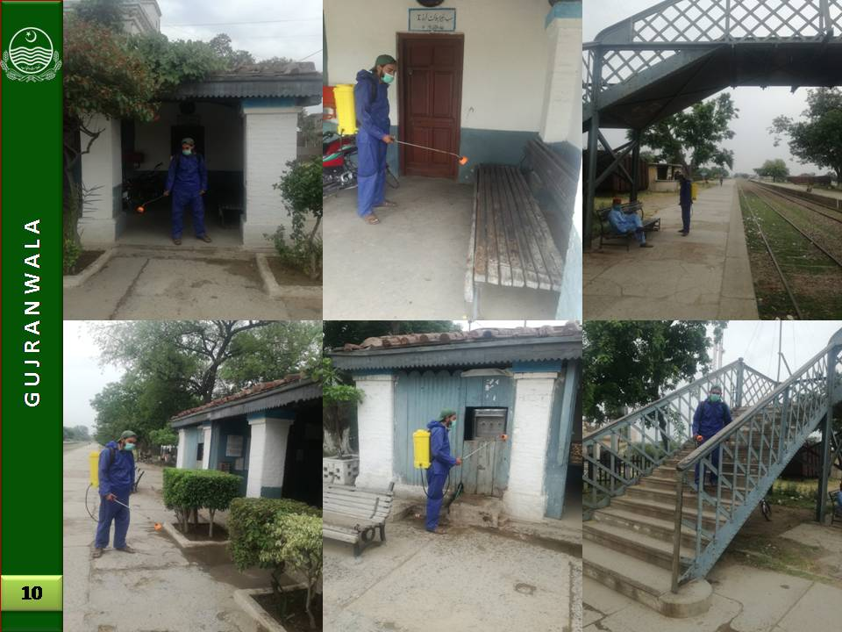 | 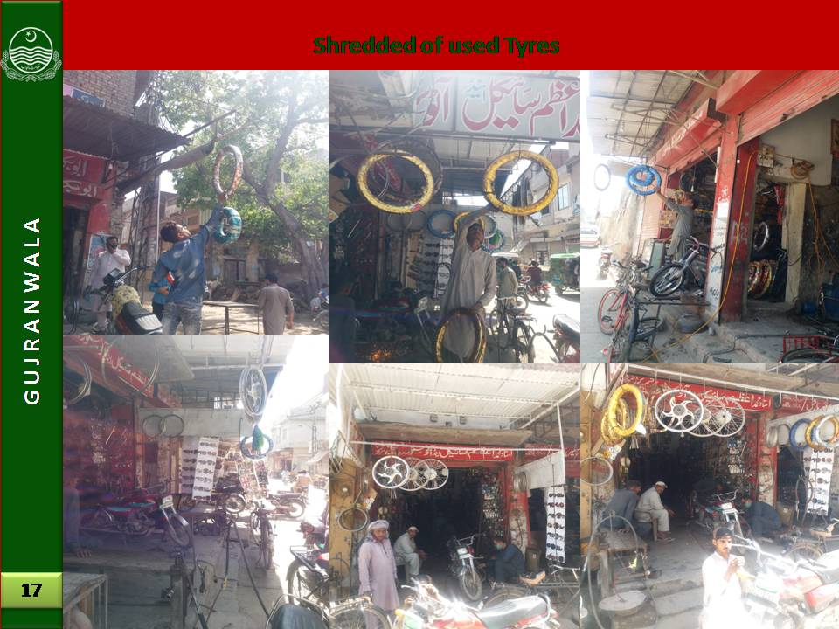
 | 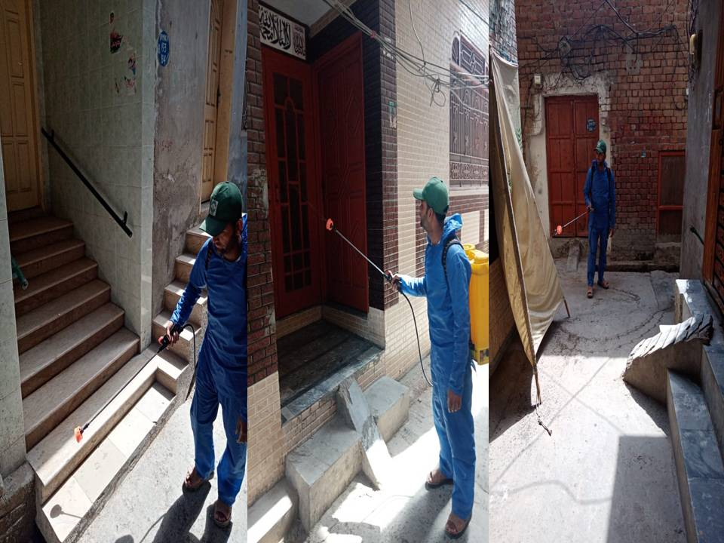

Trainings & Hands-on Sessions

LG&CD Department with the technical assistance of Punjab Municipal Development Fund Company (PMDFC) often organized training programs and hand on sessions for MC management and staff on need basis. PMDFC team always provides continuous support to MCs’ staff for MCs institutional strengthening and capacity building and to enhance performances. Various institutional interventions such as GIS maps, Computerized Financial Management System, Performance Management System, Computerized Complaint Tracking System and MCs’ websites has been developed, implemented and make functional in MC. However, MC management and staff are putting its best efforts for accomplishing the heightened scope of work against these interventions to obtain the subsequent Performance Based Grants (PBGs) against related Performance Measures (PMs) under PCP. In this context, to fulfill the MACs and PMs under PCP, the detail of work has been chalked out and mentioned below:

Sr. No. | Interventions | Detail of Work
1 | GIS Maps | Updated GIS based maps are available with MCs  - Base maps,  - Municipal Infrastructure maps (water supply, sewerage, solid waste, Road hierarchy & streetlight)
2 | Computerized Financial Management System (CFMS) | - Budget Entry for the current financial year  - Cash book entry for the current financial year  - Receipts  - Expenditures
3 | Performance Management System (PMS) | - Reports on Performance Indicators to track status of municipal services i.e. water supply, sanitation and streetlights:  - Expenditures details on various municipal services i.e. water supply, solid waste, street lights as per information provided by MCs  - Customized reporting as per requirement
4 | Computerized Complaint Tracking System (CCTS) | - Registration of complaints in the web based software  - Sector wise (Water Supply, Solid Waste, Street Light, Sewerage System etc) reports  - Different analyses of resolved & unresolved complaints  - Information pertaining complaint registration and resolution time
5 | MC Websites | Update the links on MC website on regular/ need basis  - News & Event  - Notice & Tenders  - Administrative setup (Name of officer, date of joining, qualification, total service, contact No)  - Budget  - Incumbency  - Other website links
Actions accomplished for implementation of the interventions
A. MCs designated the officials to manage the interventions
B. Refresher Trainings.
C. Continuous follow-up by PMDFC
D. MCs managed requisite hardware
E. MC management were sensitized to review systems generated reports on regular basis.

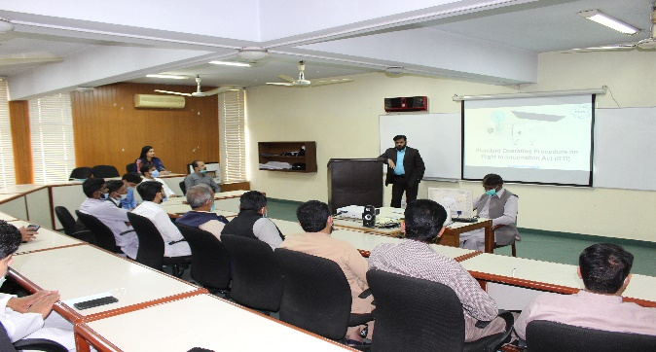 | 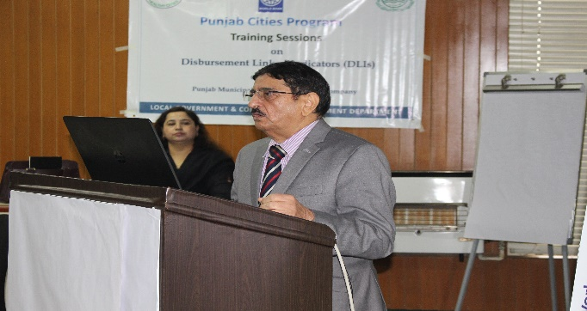
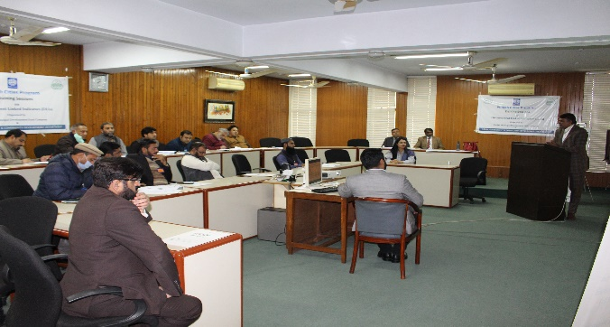 | 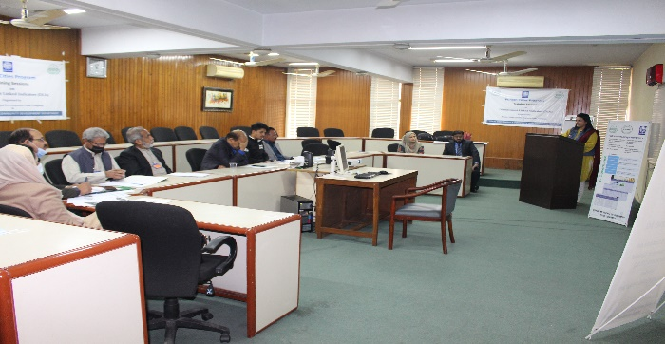
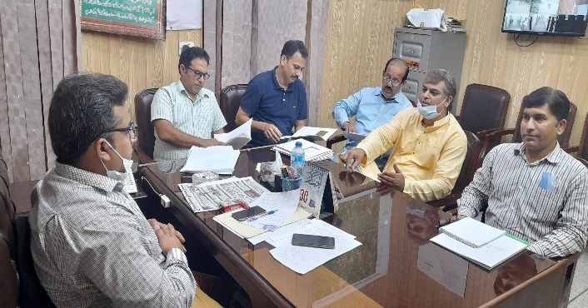 | 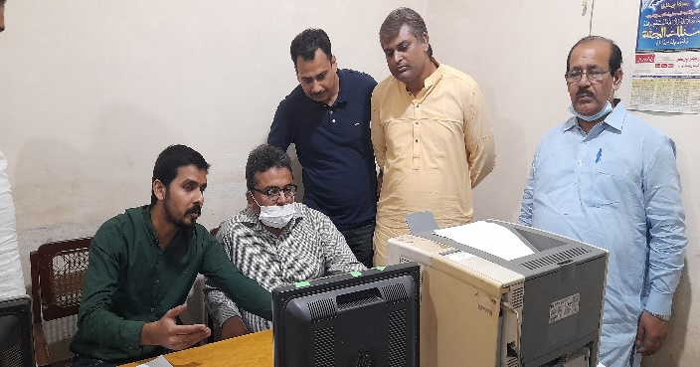
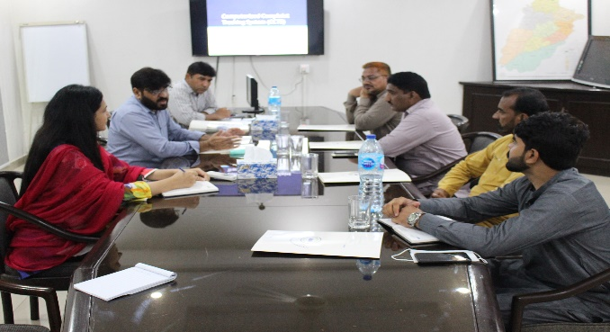 | 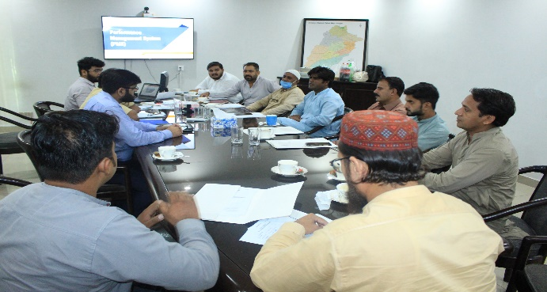

Infrastructure Projects under PCP
The detail of infrastructure projects completed under PCP during the financial year 2020-21 is as under:
(Rs. in Million)
Sr.# | Project Name | Project Detail | Duration | Project Cost
1 | Rehabilitation of Municipal Services in Kamoke City (Group-A) | I-Water supply  1- Replacement of Tube Well  2- Replacemenet of turbine pumping units  3- Installation of bulk water meters  4- External electrification  5- Construction of pump house  6- External electrification  7- Replacement of motor control units  8- Rehabilitation of filtration plants  9- Replacemenet of sluice valves  10- Replacemenet of non return valves  11- Installation of power factor improvement equipment  II-Sewerage  Rehabilitation of sullage carrier  Provision of sub mersible pump for of disposal works 3-cusic, 25HP motor with MS pipe 130-rft  Provision of sub mersible pump for of disposal works 3-cusic, 25HP motor with MS pipe 105-rft  Construction of additional manholes  Repair of disposal Stations, collecting tanks & screening chambers  Installation of power factor improvement equipments  IV- Parks  1- Rehabilitation of ladies park  V- Street Light  1- 120 watt LED lights with accessories in underpass road  2- 120 watt LED lights with accessories in lady park road | 6 | 100.092
2 | Rehabilitation of Municipal Services in Kamoke City (Group-C) | I-Sewerage  1- Provision of winch machines for desilting of sewer lines  2- Provision of Back-Hoe machine for de silting of sullage carriers  3- Supply of manhole covers with base frame  4- Supply of non-clogging sullage pump | 6 | 8.620

Municipal Services Delivery Detail

Water supply system

Water supply hours
On an average MC is supplying 11 hours of water to households daily as per given schedule

Water Supplied Hours
Morning | Midday | Evening | Total
4 | 2 | 5 | 11

9.1.2 Total coverage of the city
The total area coverage of water supply in the city is approximately 10%. Out of served area 34 % area falls under water shortage and 12 % under the water contamination.

No. of Connections |  |  |  | %age connected
Domestic | Commercial | Industrial | Total
1232 | 39 | Nil | 1271 | 4%

Tariff structure
The water rates are given below;

Tariff Rates per month
Domestic | Commercial | Industrial
Rs. 50 | Rs. 70 | Nil

Water Filtration Plants:
Only one overhead reservoir is operative in the entire water supply system which is used to feed water to filtration plant.

Manpower Deployment
Slot | Sanctioned strength | Existing strength | Vacant post | Manpower on daily wages | Total man power deployed
Tube-well operators | 3 | 3 | - | - | 3
Chowki  Dars | 2 | 1 | 1 | - | 1
Electricians | 1 | 1 | - | - | 1
Plumbers | 2 | 2 | - | - | 2
Plumber helpers | 1 | 1 | - | - | 1
Water Rate Clerk | 1 | 1 | - | - | 1
Total | 10 | 9 | 1 | - | 9
The vacant positions of the field staff need to be filled for satisfactory service delivery.

Solid Waste Management

Solid Waste Generation & Disposal
The solid waste management efficiency along with present dumping sites is given below;

Total Waste Generated in a year | 30,195 Ton
Avg. Generation of Solid Waste per Month | 3,450 Ton
Avg. Solid Waste Disposed of per Month | 2,475 Ton
% age Efficiency per Month | 72%

Equipment & Machinery
Under mentioned collection and transportation machinery is available with MC to handle the solid waste.

S.N | Equipment/machinery | Total available  Nos. | Working
1 | Tractor Trolleys | 10 | 10
2 | Arm Roll Truck | 2 | 2
3 | 5.0 m3 Containers | 29 | 29
4 | Front Blade Tractors | 1 | 1
5 | Front End Loaders | 3 | 3
6 | Water Bowsers | 2 | 2
7 | Mechanical Sweepers | 2 | 2
9 | Hand Carts Type-I | 150 | 150
10 | Loader Rickshaw | 3 | 3
11 | Jetting Machine | 1 | 1
12 | Sucker Machine | 1 | 1
13 | De-Watering Pump | 10 | 10
14 | Fog Machine | 3 | 3
15 | Spray Machine | 4 | 4
16 | Mini Dumper / Auto Rickshaw | 4 | 4

The existing machinery is neither sufficient nor cost effective and efficient giving rise to low efficiency of collection and disposal of the waste and as a result of that MC is facing higher waste management cost as well as complaints regarding the insanitary conditions in the city. Presently 16 communal containers and are needing repairs whereas 70 hand carts need to be either repaired or replace.

Efficient and cost effective machinery is needed to increase the efficiency of collection and disposal of waste for improving the sanitary conditions and lowering down the operational and maintenance costs.

Manpower Deployed
The manpower deployed for collection, transportation and disposal of the solid waste is given in the table below. As indicated by MC Officers, this manpower is not sufficient to serve the entire city at the given standards. Actual requirement will be identified after detail design and implementation of the project.

Slot | Sanctioned strength | Existing strength | Vacant posts | Manpower on daily wages | Total manpower deployed
Sanitary workers | 141 | 141 | 0 | - | 141
Vehicle drivers | 4 | 4 | 0 | - | 4
Supervisors | 4 | 4 | 0 | - | 4
Sanitary Inspectors | 2 | 1 | 1 | - | 1
Total | 151 | 150 | 0 | - | 150

Coverage Detail
The entire city is not served with solid waste collection and disposal. 60% area of the city is fully served, 15% is partially served and 25% is un-served as marked on the map. In partially served areas service is rendered intermittently depending upon availability of manpower and transportation machinery. The city is fully served, 60% is partially served and 25% is un-served as marked on the map. In partially served areas service is rendered intermittently depending upon availability of manpower and transportation machinery.
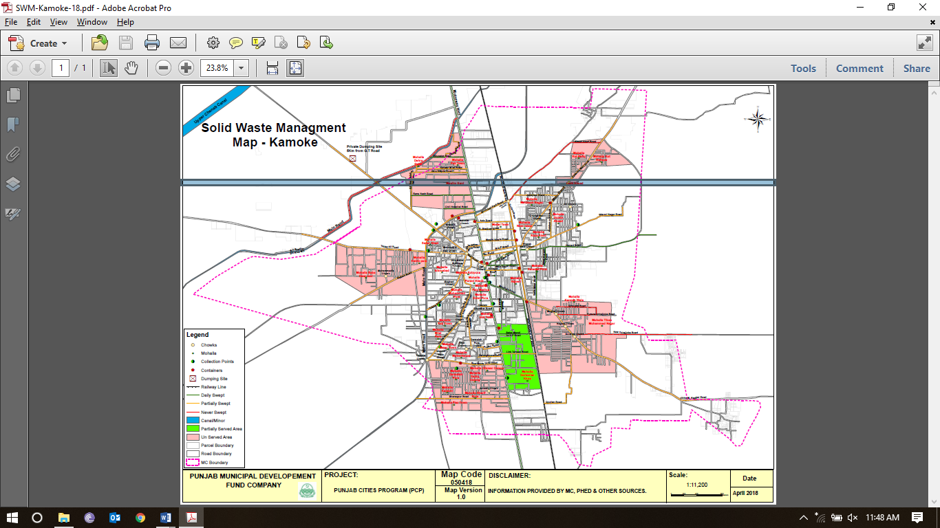

- Partially served areas
No regular service is rendered in the under mentioned areas. The main complaints are attended by sending the machinery & labor once or twice a week.

1 | Sheesh Mehal road | 2 | SabziMandi road | 3 | Link Tehsil road
4 | Mohallah Darbarian Khoo | 5 | Madina town (partly)

- Unserved areas
Under mentioned areas are still unserved;

1 | Kot Rafique | 2 | Olakhabad | 3 | Mohallah Karman Wala
4 | Tibaa Mohammad Nagar | 5 | Gulshan Chowk | 6 | Nagina Chowk
7 | Mughal Chowk | 8 | Model Town | 9 | Pak Town
10 | Dera Gujran | 11 | Satellite Town | 12 | Rana Nazir Road
13 | Habib Pura | 14 | Mohallah Islamabad | 15 | Dera Baba Jani
16 | Fiaz Town | 17 | Bilal Park | 18 | Akbar Town
19 | Mubarik Pura | 20 | Dilawar Colony | 21 | Darwesh Pura
22 | Sadiq Colony | 23 | Mohallah Karachi | 24 | Shaifque Pura
25 | Fiaz Town | 26 | Madina Town

    - Landfill development
Approximate area of 20 acres will be required for the next 10 years for construction of landfills for safe and sanitary disposal of the solid waste of the city. Presently the waste is being dumped in depressions belonging to a private land near Maari Road village with an area of 2 acres. MC is trying to procure land near kamoke for landfill. The suitability of the landfill site will be determined after detailed surveys and design of the project by catering the requirement of the environmental standards in vogue in Punjab.

    - Vehicle parking Area:
MC has no built-up parking area at present. Vehicles are parked in the Over Head Reservoir (OHR) premises near main G.T road. Land with area of 5 kanals is available near the OHR, which is required to be converted in to proper parking area by construction of parking sheds, vehicle washing and service arrangements, small office and other allied facilities.

    - Levying of sanitation fees
No sanitation fee has been levied by MC and the entire expenditure given below is being met from MC’s own resources and the PFC share being given by Provincial government.

Sewerage

Coverage
The city has 60% coverage of sewerage system but only the main and branch sewers have been laid and the lateral sewers have not been provided in most of the city. The city is mostly served by the surface drains discharging in main and branch sewers leading to Sharif pura disposal station.

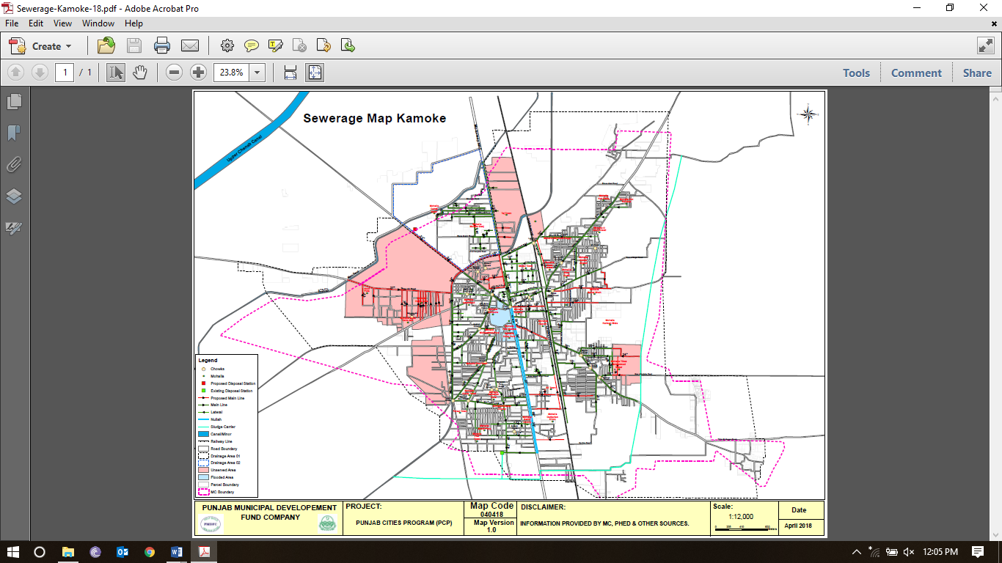

Existing pumping / disposal stations

The details of each pumping stations constructed in the city is given below;
Location | Nos of collect. Tanks | Nos of pumps | Discharge each (cusecs) | Total discharge (cusecs) | Motor HP | Working status | Sullage carrier |  |  | Ultimate disposal
 |  |  |  |  |  |  | Size (inch) | Length (ft) | Cond.
Sharif pura disposal station | 02 | 08 | 8.0 | 64.0 | 75 | Fair | 4’x6’ | 1500’ | Fair | Ghania drain
Mari Road disposal | Abandoned now and waste water from sewers is directly discharged in Ghania storm water drain which may be causing the silting up of sewers.

Manpower deployed
The manpower deployed presently for the operation & maintenance of the system is given below against the total regular strength of 8 persons.

Pump Operators | 2
Baildars | 1
Supervisors | 1
Sewer Men | 4
Total | 8

The manpower deployed presently is not enough to operate and maintain the system and the sewers cannot be de-silted. Additional manpower is required to save the system for chocking.

Tariff structure
There are 5,820 sewer connections within MC Kamoke and not being charged.

Drainage zones
The city has been divided in 2 zones with respect of the waste water drainage. Each zone with its coverage is described below;

- Zone-1
This zone is comprised of areas lying in north western side of the G.T road. The disposal station on the Mari road for this zone has been abandoned due to old machinery and structures. Currently waste water of this zone is being disposed in Khooth seepage drain through two main sewers under gravity.

- Zone-2
This zone comprises of almost 85% area of the city. The waste water of this zone is currently disposed through 72” main sewer in to Sharif pura disposal station and ultimately in to Ghania seepage/storm water drain. Sewers in some areas are choked and mentioned in blue color which causes flooding as marked on the map. Two main sullage carriers flowing along both sides of G.T road are discharging into 72” dia outfall sewer and need major rehabilitation. Flooding due to storm water also occurs in some areas as marked on the map. Lateral sewers are missing in major portion of the city. Waste water from primary & secondary drains is collected in to branch sewers without gully grating chambers, which causes chocking of sewers.

Streetlight
Street light facility is available only one road. No proper poles have been installed for street light. MC requires the street lights on major roads and streets.

Ward wise detail of existing streetlights
Energy saver bulbs are being used instead of LED lamps which are fulfilling the requirements in different Mohallas

S. No. | Name of Mohalla | No. of Street Lights | S. No. | Name of Mohalla | No. of Street Lights
1 | Ward No. 1 | 0 | 19 | Ward No. 19 | 0
2 | Ward No. 2 | 0 | 20 | Ward No. 20 | 0
3 | Ward No. 3 | 0 | 21 | Ward No. 21 | 0
4 | Ward No. 4 | 0 | 22 | Ward No. 22 | 0
5 | Ward No. 5 | 0 | 23 | Ward No. 23 | 0
6 | Ward No. 6 | 0 | 24 | Ward No. 24 | 0
7 | Ward No. 7 | 0 | 25 | Ward No. 25 | 0
8 | Ward No. 8 | 0 | 26 | Ward No. 26 | 0
9 | Ward No. 9 | 0 | 27 | Ward No. 27 | 0
10 | Ward No. 10 | 0 | 28 | Ward No. 28 | 0
11 | Ward No. 11 | 0 | 29 | Ward No. 29 | 0
12 | Ward No. 12 | 0 | 30 | Ward No. 30 | 0
13 | Ward No. 13 | 0 | 31 | Ward No. 31 | 0
14 | Ward No. 14 | 0 | 32 | Ward No. 32 | 0
15 | Ward No. 15 | 0 | 33 | Ward No. 33 | 0
16 | Ward No. 16 | 0 | 34 | Ward No. 34 | 0
17 | Ward No. 17 | 0 | 35 | Ward No. 35 | 0
18 | Ward No. 18 | 0 | 36 | Ward No. 36 | 0
 | Total | 0

Replacement of luminaries

Replacement of existing lights by LED’s has been proposed on the following roads.

Sr # | Name of road/street | Length (Km) | No. of Luminaries to be replaced | Installation of Photo Electric switch
R1 | Lady Park Road | 0.5 | 30 | 01
R2 | Underpass Road | 0.4 | 0 | 0

Provision of New Street Lights
The detail of the proposed provision of services is as follows:

Sr # | Name of road/street | Length (Km)
N1 | Neelum cinema Road | 0.5
N2 | Main Bazar Road Kamoke | 0.4
N3 | Imam Barghah Road | 0.6
N4 | Harar Road to Baharshah Graveyard | 0.8
N5 | Rasool Nagar Road | 0.8
N6 | Kasoki Road | 2.0
N7 | Tiba Muhammad Nagar Road | 2.25
N8 | Mandiala Road to Phatak | 0.6
N9 | GT road to Chowk Ghausia | 0.3
N10 | Mari Road | 0.7
N11 | Tatle Wali Road | 0.7
N12 | Ghalla Mandi (exchange road) | 0.5
N13 | Masjid Nimra road to Neelam Cinema Road along G.T road | 4.0

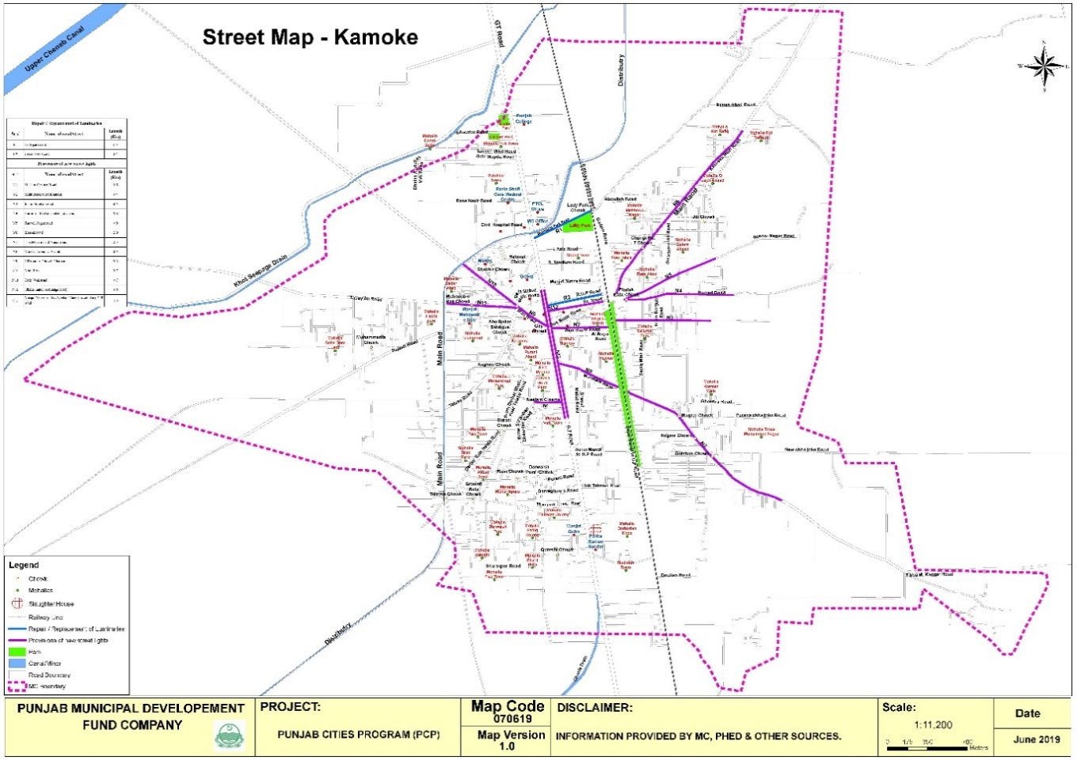

Complaint Management

Municipal Committee Kamoke has established a centralized complaint cell for complaints registration, its tracking and resolution. The primary objective of establishing complaint cell was to enhance MC’s efficiency in addressing citizens’ and building confidence of citizens.

The complaint cell has been provided with telephone line to facilitate the complaint registration over the phone without walking in to the office. Every complaint, whether received in writing or verbally, is recorded in the software by a designated complaint cell in charge. Each recorded complaint generates a unique number already printed on the complaint slip. The complainant also receives the complaint number for the follow up, if required. Once the complaint is resolved by the relevant staff, he returns his part of the complaint slip to the complaint cell with his remarks and the complaint cell in charge updates the status of complaint in the software accordingly. The complainant may inquire the status of his complaint at any time just by calling the complaint registration office with reference to his complaint number. This process ensures the registration and tracking of all the complaints, thus keeping MC staff accountable to the MC management as well as the citizens.

Complaints: Received Summary Year – 2020-21
Sector | Complaints
Water Supply | 2%
Sewerage and Drainage | 89%
Streetlight | 3%
Solid waste | 5%
Regulation | 2%
Percentage Resolved | 100%

MC Website (www.mckamoke.lgpunjab.org.pk)

Municipal Committee Kamoke has also developed its website for dissemination of information for general public. The information contain all major categories of information for citizen’s interest like information about the officers with their telephone numbers, budget detail, Development projects, news and events.

Annex A
Final Detail of Human Resource
Sr. No. | BPS | Designation | Sanctioned |  |  | Filled |  |  | Vacant |  |  | Recruitment  Planned for Next  Year |  |  | Total  Establishment  (Filled +  Recruitment)
 |  |  | M | F | Total | M | F | Total | M | F | Total | M | F | Total | M | F | Total
Mayor
1 | Fixed | Mayor Municipal Committee | 1 | 0 | 1 | 0 | 0 | 0 | 1 | 0 | 1 | 0 | 0 | 0 | 1 |  | 1
2 | 14 | Senior Clerk | 1 | 0 | 1 | 0 | 0 | 0 | 1 | 0 | 1 | 0 | 0 | 0 | 1 |  | 1
3 | 11 | Junior Clerk | 1 | 0 | 1 | 1 | 0 | 1 | 0 | 0 | 0 | 0 | 0 | 0 | 1 |  | 1
4 | 12 | Junior Computer Operator | 1 | 0 | 1 | 0 | 0 | 0 | 1 | 0 | 1 | 0 | 0 | 0 | 1 |  | 1
5 | 4 | Driver | 1 | 0 | 1 | 1 | 0 | 1 | 0 | 0 | 0 | 0 | 0 | 0 | 1 |  | 1
6 | 1 | Office Boy | 1 | 0 | 1 | 0 | 0 | 0 | 1 | 0 | 1 | 0 | 0 | 0 | 1 |  | 1
7 | 5 | Octori Naib Qasid | 1 | 0 | 1 | 0 | 0 | 0 | 1 | 0 | 1 | 0 | 0 | 0 | 1 |  | 1
 | Total: |  | 7 | 0 | 7 | 2 | 0 | 2 | 5 | 0 | 5 | 0 | 0 | 0 | 7 | 0 | 7
Chief Officer
1 | 19 | Chief Officer | 1 | 0 | 1 | 1 | 0 | 1 | 0 | 0 | 0 | 0 | 0 | 0 | 1 |  | 1
2 | 16 | Office Assistant | 1 | 0 | 1 | 1 | 0 | 1 | 0 | 0 | 0 | 0 | 0 | 0 | 1 |  | 1
3 | 14 | Senior Clerk | 1 | 0 | 1 | 1 | 0 | 1 | 0 | 0 | 0 | 0 | 0 | 0 | 1 |  | 1
4 | 12 | Junior Computer Operator | 1 | 0 | 1 | 1 | 0 | 1 | 0 | 0 | 0 | 0 | 0 | 0 | 1 |  | 1
5 | 12 | Personal Assistant | 1 | 0 | 1 | 1 | 0 | 1 | 0 | 0 | 0 | 0 | 0 | 0 | 1 |  | 1
6 | 14 | Octori Clerk | 2 | 0 | 2 | 2 | 0 | 2 | 0 | 0 | 0 | 0 | 0 | 0 | 2 |  | 2
7 | 11 | Junior Clerk | 2 | 0 | 1 | 2 | 0 | 2 | 0 | 0 | 0 | 0 | 0 | 0 | 2 |  | 2
8 | 11 | Octori Clerk | 1 | 0 | 1 | 1 | 0 | 1 | 0 | 0 | 0 | 0 | 0 | 0 | 1 |  | 1
9 | 11 | Record Keeper | 1 | 0 | 1 | 1 | 0 | 1 | 0 | 0 | 0 | 0 | 0 | 0 | 1 |  | 1
10 | 5 | Imam Masjid | 1 | 0 | 1 | 1 | 0 | 1 | 0 | 0 | 0 | 0 | 0 | 0 | 1 |  | 1
11 | 2 | Octori Naib Qasid | 1 | 0 | 1 | 1 | 0 | 1 | 0 | 0 | 0 | 0 | 0 | 0 | 1 |  | 1
12 | 1 | Dak Runner | 1 | 0 | 1 | 1 | 0 | 1 | 0 | 0 | 0 | 0 | 0 | 0 | 1 |  | 1
13 | 4 | Driver | 1 | 0 | 1 | 1 | 0 | 1 | 0 | 0 | 0 | 0 | 0 | 0 | 1 |  | 1
14 | 1 | Chowkidar | 1 | 0 | 1 | 1 | 0 | 1 | 0 | 0 | 0 | 0 | 0 | 0 | 1 |  | 1
15 | 1 | Sweeper | 1 | 0 | 1 | 0 | 0 | 0 | 1 | 0 | 1 | 0 | 0 | 0 | 1 |  | 1
16 | 1 | Office Boy | 2 | 0 | 2 | 0 | 0 | 0 | 2 |  | 2 | 0 | 0 | 0 | 2 |  | 2
17 | 1 | Naib Qasid | 1 | 0 | 1 | 1 | 0 | 1 | 0 | 0 | 0 | 0 | 0 | 0 | 1 |  | 1
18 | Fixed | Legal Advisor | 1 |  | 1 | 1 | 0 | 1 | 0 | 0 | 0 | 0 | 0 | 0 | 1 |  | 1
 | Total: |  | 21 | 0 | 20 | 18 | 0 | 18 | 3 | 0 | 3 | 0 | 0 | 0 | 21 | 0 | 21
Municipal Officer (IT)
1 | 17 | Municipal Officer (IT) | 1 | 0 | 1 | 0 | 0 | 0 | 1 | 0 | 1 | 0 | 0 | 0 | 1 |  | 1
2 | 12 | Junior Computer Operator( IT Assistant ) | 3 | 0 | 3 | 0 | 0 | 0 | 3 | 0 | 3 | 0 | 0 | 0 | 3 |  | 3
3 | 11 | Octori Clerk | 2 | 0 | 2 | 2 | 0 | 2 | 0 | 0 | 0 | 0 | 0 | 0 | 2 |  | 2
4 | 1 | Office Boy | 1 | 0 | 1 | 0 | 0 | 0 | 1 | 0 | 1 | 0 | 0 | 0 | 1 |  | 1
5 | 2 | Octori Naib Qasid | 1 | 0 | 1 | 1 | 0 | 1 | 0 | 0 | 0 | 0 | 0 | 0 | 1 |  | 1
 | Total: |  | 8 | 0 | 8 | 3 | 0 | 3 | 5 | 0 | 5 | 0 | 0 | 0 | 8 | 0 | 8
Municipal Officer (Finance)
1 | 18 | Municipal Officer (Finance) | 1 | 0 | 1 | 1 | 0 | 1 | 0 | 0 | 0 | 0 | 0 | 0 | 1 |  | 1
2 | 16 | Office Assistant | 1 | 0 | 1 | 0 | 0 | 0 | 1 |  | 1 | 0 | 0 | 0 | 1 |  | 1
3 | 14 | Accountant (LGS) | 1 | 0 | 1 | 0 | 0 | 0 | 1 | 0 | 1 | 0 | 0 | 0 | 1 |  | 1
4 | 14 | Senior Clerk | 1 | 0 | 1 | 1 | 0 | 1 | 0 | 0 | 0 | 0 | 0 | 0 | 1 |  | 1
5 | 14 | Octori Clerk | 2 | 0 | 2 | 2 | 0 | 2 | 0 | 0 | 0 | 0 | 0 | 0 | 2 |  | 2
6 | 11 | Junior Clerk | 4 | 0 | 4 | 4 | 0 | 4 | 0 | 0 | 0 | 0 | 0 | 0 | 4 |  | 4
7 | 11 | Octori Clerk | 2 | 0 | 2 | 2 | 0 | 2 | 0 | 0 | 0 | 0 | 0 | 0 | 2 |  | 2
8 | 11 | Cashier | 1 | 0 | 1 | 1 | 0 | 1 | 0 | 0 | 0 | 0 | 0 | 0 | 1 |  | 1
9 | 14 | Tax Inspector | 1 | 0 | 1 | 1 | 0 | 1 | 0 | 0 | 0 | 0 | 0 | 0 | 1 |  | 1
10 | 14 | License Inspector | 1 | 0 | 1 | 1 | 0 | 1 | 0 | 0 | 0 | 0 | 0 | 0 | 1 |  | 1
11 | 14 | Rent Inspector | 1 | 0 | 1 | 1 | 0 | 1 | 0 | 0 | 0 | 0 | 0 | 0 | 1 |  | 1
12 | 11 | Slaughter House Clerk | 1 | 0 | 1 | 1 | 0 | 1 | 0 | 0 | 0 | 0 | 0 | 0 | 1 |  | 1
13 | 3 | Octori Naib Qasid | 1 | 0 | 1 | 1 | 0 | 1 | 0 | 0 | 0 | 0 | 0 | 0 | 1 |  | 1
14 | 2 | Naib Qasid | 1 | 0 | 1 | 1 | 0 | 1 | 0 | 0 | 0 | 0 | 0 | 0 | 1 |  | 1
15 | 2 | Octori Naib Qasid | 1 | 0 | 1 | 1 | 0 | 1 | 0 | 0 | 0 | 0 | 0 | 0 | 1 |  | 1
16 | 1 | Chowkidar Slaughter House | 1 | 0 | 1 | 1 | 0 | 1 | 0 | 0 | 0 | 0 | 0 | 0 | 1 |  | 1
17 | Fixed | Superintendent Slaughter House | 1 | 0 | 1 | 1 | 0 | 1 | 0 | 0 | 0 | 0 | 0 | 0 | 1 |  | 1
18 | 1 | Office Boy | 2 | 0 | 2 | 0 | 0 | 0 | 2 | 0 | 2 | 0 | 0 | 0 | 2 |  | 2
 | Total: |  | 24 | 0 | 24 | 20 | 0 | 20 | 4 | 0 | 4 | 0 | 0 | 0 | 24 | 0 | 24
Municipal Officer (Planning)
1 | 18 | Municipal Officer (Planning) (LGS) | 1 | 0 | 1 | 1 | 0 | 1 | 0 | 0 | 0 | 0 | 0 | 0 | 1 |  | 1
2 | 14 | Building Inspector | 4 | 0 | 4 | 1 | 0 | 1 | 3 | 0 | 3 | 0 | 0 | 0 | 4 |  | 4
3 | 14 | Senior Clerk | 1 | 0 | 1 | 1 | 0 | 1 | 0 | 0 | 0 | 0 | 0 | 0 | 1 |  | 1
4 | 15 | Accounts Clerk | 1 | 0 | 1 | 1 | 0 | 1 | 0 | 0 | 0 | 0 | 0 | 0 | 1 |  | 1
5 | 11 | Junior Clerk | 1 | 0 | 1 | 1 | 0 | 1 | 0 | 0 | 0 | 0 | 0 | 0 | 1 |  | 1
6 | 11 | Octori Clerk | 1 | 0 | 1 | 1 | 0 | 1 | 0 | 0 | 0 | 0 | 0 | 0 | 1 |  | 1
7 | 2 | Naib Qasid | 1 | 0 | 1 | 1 | 0 | 1 | 0 | 0 | 0 | 0 | 0 | 0 | 1 |  | 1
8 | 1 | Office Boy | 1 | 0 | 1 | 0 | 0 | 0 | 1 | 0 | 1 | 0 | 0 | 0 | 1 |  | 1
 | Total: |  | 11 | 0 | 11 | 7 | 0 | 7 | 4 | 0 | 4 | 0 | 0 | 0 | 11 | 0 | 11
Municipal Officer (Archt)
1 | 17 | Municipal Officer (Archt) | 1 | 0 | 1 | 0 | 0 | 0 | 1 | 0 | 1 | 0 | 0 | 0 | 1 |  | 1
2 | 14 | Octori Clerk | 1 | 0 | 1 | 1 | 0 | 1 | 0 | 0 | 0 | 0 | 0 | 0 | 1 |  | 1
3 | 11 | Octori Clerk | 1 | 0 | 1 | 1 | 0 | 1 | 0 | 0 | 0 | 0 | 0 | 0 | 1 |  | 1
4 | 5 | Octori Naib Qasid | 1 | 0 | 1 | 1 | 0 | 1 | 0 | 0 | 0 | 0 | 0 | 0 | 1 |  | 1
5 | 1 | Office Boy | 1 | 0 | 1 | 0 | 0 | 0 | 1 | 0 | 1 | 0 | 0 | 0 | 1 |  | 1
 | Total: |  | 5 | 0 | 5 | 3 | 0 | 3 | 2 | 0 | 2 | 0 | 0 | 0 | 5 | 0 | 5
Municipal Officer (Regulation)
1 | 18 | Municipal Officer (Regulation) | 0 | 1 | 1 | 0 | 1 | 1 | 0 | 0 | 0 | 0 | 0 | 0 | 1 |  | 1
2 | 15 | Stenographer | 1 | 0 | 1 | 1 | 0 | 1 | 0 | 0 | 0 | 0 | 0 | 0 | 1 |  | 1
3 | 12 | Personal Assistant | 1 | 0 | 1 | 1 | 0 | 1 | 0 | 0 | 0 | 0 | 0 | 0 | 1 |  | 1
4 | 14 | Octori Clerk | 2 | 0 | 2 | 2 | 0 | 2 | 0 | 0 | 0 | 0 | 0 | 0 | 2 |  | 2
5 | 11 | Transport Clerk | 1 | 0 | 1 | 1 | 0 | 1 | 0 | 0 | 0 | 0 | 0 | 0 | 1 |  | 1
6 | 11 | Food Clerk | 1 | 0 | 1 | 1 | 0 | 1 | 0 | 0 | 0 | 0 | 0 | 0 | 1 |  | 1
7 | 11 | Water Rate Clerk | 1 | 0 | 1 | 1 | 0 | 1 | 0 | 0 | 0 | 0 | 0 | 0 | 1 |  | 1
8 | 3 | Mashki | 1 | 0 | 1 | 1 | 0 | 1 | 0 | 0 | 0 | 0 | 0 | 0 | 1 |  | 1
9 | 2 | Naib Qasid | 1 | 0 | 1 | 1 | 0 | 1 | 0 | 0 | 0 | 0 | 0 | 0 | 1 |  | 1
10 | 1 | Water Carrier | 2 | 0 | 2 | 2 | 0 | 2 | 0 | 0 | 0 | 0 | 0 | 0 | 2 |  | 2
11 | 11 | OSD | 1 | 0 | 1 | 1 | 0 | 1 | 0 | 0 | 0 | 0 | 0 | 0 | 1 |  | 1
12 | 4 | OSD | 1 | 0 | 1 | 1 | 0 | 1 | 0 | 0 | 0 | 0 | 0 | 0 | 1 |  | 1
13 | 4 | Paida | 1 | 0 | 1 | 1 | 0 | 1 | 0 | 0 | 0 | 0 | 0 | 0 | 1 |  | 1
14 | 1 | Paida | 1 | 0 | 1 | 1 | 0 | 1 | 0 | 0 | 0 | 0 | 0 | 0 | 1 |  | 1
15 | 4 | Driver | 1 | 0 | 1 | 1 | 0 | 1 | 0 | 0 | 0 | 0 | 0 | 0 | 1 |  | 1
16 | 1 | Office Boy | 1 | 0 | 1 | 0 | 0 | 0 | 1 | 0 | 1 | 0 | 0 | 0 | 1 |  | 1
 | Total: |  | 17 | 1 | 18 | 16 | 1 | 17 | 1 | 0 | 1 | 0 | 0 | 0 | 18 | 0 | 18
M.O (Infrastructure )
1 | 18 | Municipal Officer (I&S) | 1 | 0 | 1 | 1 | 0 | 1 | 0 | 0 | 0 | 0 | 0 | 0 | 1 |  | 1
2 | 16 | Senior Sub Engineer (LGS) | 1 | 0 | 1 | 0 | 0 | 0 | 1 | 0 | 1 | 0 | 0 | 0 | 1 |  | 1
3 | 16 | Assistant | 1 | 0 | 1 | 0 | 0 | 0 | 1 | 0 | 1 | 0 | 0 | 0 | 1 |  | 1
4 | 15 | Draftsman | 1 | 0 | 1 | 0 | 0 | 0 | 1 | 0 | 1 | 0 | 0 | 0 | 1 |  | 1
5 | 15 | Stenographer | 1 | 0 | 1 | 1 | 0 | 1 | 0 | 0 | 0 | 0 | 0 | 0 | 1 |  | 1
6 | 12 | Personal Assistant | 1 | 0 | 1 | 1 | 0 | 1 | 0 | 0 | 0 | 0 | 0 | 0 | 1 |  | 1
7 | 14 | Octori Clerk | 3 | 0 | 3 | 3 | 0 | 3 | 0 | 0 | 0 | 0 | 0 | 0 | 3 |  | 3
8 | 14 | Light Inspector | 1 | 0 | 1 | 1 | 0 | 1 | 0 | 0 | 0 | 0 | 0 | 0 | 1 |  | 1
9 | 14 | Sub Engineer (LCS) | 2 | 0 | 2 | 2 | 0 | 2 | 0 | 0 | 0 | 0 | 0 | 0 | 2 |  | 2
10 | 14 | Sub Engineer (H&PP) | 1 | 0 | 1 | 1 | 0 | 1 | 0 | 0 | 0 | 0 | 0 | 0 | 1 |  | 1
11 | 14 | Sub Engineer (LGS) | 4 | 0 | 4 | 1 | 0 | 1 | 3 | 0 | 3 | 0 | 0 | 0 | 4 |  | 4
12 | 11 | Octori Clerk | 1 | 0 | 1 | 1 | 0 | 1 | 0 | 0 | 0 | 0 | 0 | 0 | 1 |  | 1
13 | 11 | ASDC/Junior Clerk | 1 | 0 | 1 | 1 | 0 | 1 | 0 | 0 | 0 | 0 | 0 | 0 | 1 |  | 1
14 | 14 | Octori Clerk | 1 | 0 | 1 | 1 | 0 | 1 | 0 | 0 | 0 | 0 | 0 | 0 | 1 |  | 1
15 | 9 | Electrical Supervisor | 1 | 0 | 1 | 1 | 0 | 1 | 0 | 0 | 0 | 0 | 0 | 0 | 1 |  | 1
16 | 8 | Sanitary Inspector | 2 | 0 | 2 | 1 | 0 | 1 | 1 | 0 | 1 | 0 | 0 | 0 | 2 |  | 2
17 | 5 | Electrician | 5 | 0 | 5 | 5 | 0 | 5 | 0 | 0 | 0 | 0 | 0 | 0 | 5 |  | 5
18 | 5 | Sanitatary Supervisor | 6 | 0 | 6 | 4 | 0 | 4 | 2 | 0 | 2 | 0 | 0 | 0 | 6 |  | 6
19 | 7 | Tubewell Operator | 1 | 0 | 1 | 1 | 0 | 1 | 0 | 0 | 0 | 0 | 0 | 0 | 1 |  | 1
20 | 5 | Tubewell Operator | 4 | 0 | 4 | 1 | 0 | 1 | 3 | 0 | 3 | 0 | 0 | 0 | 4 |  | 4
21 | 5 | Plumber | 1 | 0 | 1 | 0 | 0 | 0 | 1 | 0 | 1 | 0 | 0 | 0 | 1 |  | 1
22 | 5 | Jeep Driver | 1 | 0 | 1 | 1 | 0 | 1 | 0 | 0 | 0 | 0 | 0 | 0 | 1 |  | 1
23 | 4 | Driver Mechinal Sweeper | 1 | 0 | 1 | 0 | 0 | 0 | 1 | 0 | 1 | 0 | 0 | 0 | 1 |  | 1
24 | 4 | Tractor Driver | 9 | 0 | 9 | 4 | 0 | 4 | 5 | 0 | 5 | 0 | 0 | 0 | 9 |  | 9
25 | 4 | Driver Sucker Machine | 1 | 0 | 1 | 0 | 0 | 0 | 1 | 0 | 1 | 0 | 0 | 0 | 1 |  | 1
26 | 4 | Driver Jetting Machine | 1 | 0 | 1 | 0 | 0 | 0 | 1 | 0 | 1 | 0 | 0 | 0 | 1 |  | 1
27 | 4 | Driver Armroll Truck | 2 | 0 | 2 | 0 | 0 | 0 | 2 | 0 | 2 | 0 | 0 | 0 | 2 |  | 2
28 | 2 | Mali | 3 | 0 | 3 | 3 | 0 | 3 | 0 | 0 | 0 | 0 | 0 | 0 | 3 |  | 3
29 | 1 | Mali | 6 | 0 | 6 | 2 | 0 | 2 | 4 | 0 | 4 | 0 | 0 | 0 | 6 |  | 6
30 | 1 | Chowkidar Disposal Station | 1 | 0 | 1 | 1 | 0 | 1 | 0 | 0 | 0 | 0 | 0 | 0 | 1 |  | 1
31 | 2 | Chowkidar | 2 | 0 | 2 | 2 | 0 | 2 | 0 | 0 | 0 | 0 | 0 | 0 | 2 |  | 2
32 | 1 | Chowkidar | 1 | 0 | 1 | 1 | 0 | 1 | 0 | 0 | 0 | 0 | 0 | 0 | 1 |  | 1
33 | 1 | Operator Dewatering Pump | 5 | 0 | 5 | 0 | 0 | 0 | 5 | 0 | 5 | 0 | 0 | 0 | 5 |  | 5
34 | 1 | Sewerman | 8 | 0 | 8 | 0 | 0 | 0 | 8 | 0 | 8 | 0 | 0 | 0 | 8 |  | 8
35 | 7 | Fireman | 3 | 0 | 3 | 3 | 0 | 3 | 0 | 0 | 0 | 0 | 0 | 0 | 3 |  | 3
36 | 9 | Motor Mechanic | 1 | 0 | 1 | 1 | 0 | 1 | 0 | 0 | 0 | 0 | 0 | 0 | 1 |  | 1
37 | 9 | Supervisor Stadium | 1 | 0 | 1 | 1 | 0 | 1 | 0 | 0 | 0 | 0 | 0 | 0 | 1 |  | 1
38 | 6 | Fireman | 1 | 0 | 1 | 1 | 0 | 1 | 0 | 0 | 0 | 0 | 0 | 0 | 1 |  | 1
39 | 6 | Fire Brigade Driver | 2 | 0 | 2 | 2 | 0 | 2 | 0 | 0 | 0 | 0 | 0 | 0 | 2 |  | 2
40 | 1 | Hepler Electrian | 1 | 0 | 1 | 1 | 0 | 1 | 0 | 0 | 0 | 0 | 0 | 0 | 1 |  | 1
41 | 4 | Hepler Electrian | 1 | 0 | 1 | 1 | 0 | 1 | 0 | 0 | 0 | 0 | 0 | 0 | 1 |  | 1
42 | 1 | Helper Plumber | 1 | 0 | 1 | 1 | 0 | 1 | 0 | 0 | 0 | 0 | 0 | 0 | 1 |  | 1
43 | 3 | Plumber Qully | 2 | 0 | 2 | 2 | 0 | 2 | 0 | 0 | 0 | 0 | 0 | 0 | 2 |  | 2
44 | 3 | Naib Qasid | 1 | 0 | 1 | 1 | 0 | 1 | 0 | 0 | 0 | 0 | 0 | 0 | 1 |  | 1
45 | 2 | Naib Qasid | 1 | 0 | 1 | 1 | 0 | 1 | 0 | 0 | 0 | 0 | 0 | 0 | 1 |  | 1
46 | 1 | Naib Qasid | 2 | 0 | 2 | 2 | 0 | 2 | 0 | 0 | 0 | 0 | 0 | 0 | 2 |  | 2
47 | 1 | Sweeper Slaughter House | 2 | 0 | 2 | 0 | 0 | 0 | 2 | 0 | 2 | 0 | 0 | 0 | 2 |  | 2
48 | 1 | Office Boy | 1 | 0 | 1 | 0 | 0 | 0 | 1 | 0 | 1 | 0 | 0 | 0 | 1 |  | 1
49 | 1 | Chowkidar Graveyard | 8 | 0 | 8 | 0 | 0 | 0 | 8 | 0 | 8 | 0 | 0 | 0 | 8 |  | 8
50 | 5 | Sanitary Worker | 6 | 0 | 6 | 6 | 0 | 6 | 0 | 0 | 0 | 0 | 0 | 0 | 6 |  | 6
51 | 4 | Sanitary Worker | 15 | 0 | 15 | 15 | 0 | 15 | 0 | 0 | 0 | 0 | 0 | 0 | 15 |  | 15
52 | 3 | Sanitary Worker | 3 | 0 | 3 | 3 | 0 | 3 | 0 | 0 | 0 | 0 | 0 | 0 | 3 |  | 3
53 | 2 | Sanitary Worker | 8 | 0 | 8 | 8 | 0 | 8 | 0 | 0 | 0 | 0 | 0 | 0 | 8 |  | 8
54 | 1 | Sanitary Worker | 227 | 5 | 232 | 99 | 5 | 104 | 128 |  | 128 |  |  | 0 | 232 |  | 232
Total: |  |  | 368 | 5 | 373 | 189 | 5 | 194 | 179 | 0 | 179 | 0 | 0 | 0 | 373 | 0 | 373
GRAND TOTAL |  |  | 461 | 6 | 466 | 258 | 6 | 264 | 203 | 0 | 203 | 0 | 0 | 0 | 467 | 0 | 467

